Intelligent AI-Based Smart Parking and Vehicle Guidance System

Field | Details
Submitted By | N. Kalyan Reddy
Register No. | 192424232
Department | AI&DS
Subject | Software Engineering
Faculty | Dr. Latha R.
College | SIMATS Engineering
Academic Year | 2024–2028

Intelligent AI-Based Smart Parking and Vehicle Guidance System
Industry Context
Rapid urbanization has increased vehicle ownership, leading to severe parking shortages and traffic
congestion in metropolitan areas. Smart parking solutions leverage AI, IoT sensors, cameras, GPS,
and cloud computing to provide real-time parking information and optimize urban mobility.
Problem Statement
Drivers spend considerable time searching for available parking spaces, increasing traffic congestion,
fuel consumption, and carbon emissions. Traditional parking management systems fail to provide
accurate real-time parking availability. An AI-powered smart parking platform should detect vacant
parking spaces using cameras and IoT sensors, guide drivers through mobile applications, predict
parking demand, automate digital payments, and support city administrators with occupancy
analytics.
Objectives
1. Detect parking availability automatically.
2. Guide drivers to vacant spaces.
3. Predict parking demand using AI.
4. Automate parking reservations.
5. Support digital payment integration.
6. Monitor parking occupancy.
7. Generate parking utilization reports.
8. Reduce urban traffic congestion.
Expected Outcomes
1. Reduced parking search time.
2. Lower traffic congestion.
3. Reduced fuel consumption.
4. Improved parking utilization.
5. Enhanced user convenience.
6. Increased parking revenue

Table of Contents
1. Understanding the Problem Statement
2. Key Stakeholders and Challenges
3. Analysis of the Current Approach
4. Proposed Software Solution Using Software Engineering Principles
5. Justification of the Chosen Methodology
6. Expected Outcomes and Limitations
7. Conclusion

1. Understanding the Problem Statement
1.1 Problem Explanation
Rapid urbanization and increasing vehicle ownership have created severe parking shortages in metropolitan cities. Drivers spend valuable time searching for available parking spaces, resulting in traffic congestion, fuel wastage, carbon emissions, and frustration. Traditional parking systems rely on manual monitoring and do not provide real-time information about parking availability.
The proposed Intelligent AI-Based Smart Parking and Vehicle Guidance System uses Artificial Intelligence (AI), IoT sensors, CCTV cameras, GPS, cloud computing, and mobile applications to detect vacant parking spaces automatically, guide drivers to available spaces, predict parking demand, support reservations, enable digital payments, and generate parking utilization reports.
1.2 Objectives
• Detect parking availability automatically.
• Guide drivers to vacant spaces.
• Predict parking demand using AI.
• Automate parking reservations.
• Support digital payments.
• Monitor parking occupancy.
• Generate parking utilization reports.
• Reduce traffic congestion.
1.3 Scope
The system manages smart parking facilities in cities, malls, airports, hospitals, universities, and commercial areas. It provides parking detection, reservation, GPS navigation, digital payments, occupancy monitoring, AI prediction, and analytics.

2. Key Stakeholders and Challenges
Stakeholders: Drivers, Parking Operators, City Administrators, System Administrator, AI Engine, IoT Sensors, Camera System, Payment Gateway.
Major Challenges:
• Long parking search time
• Traffic congestion
• Fuel wastage
• Lack of real-time parking information
• Manual monitoring
• No parking demand prediction
• Poor parking utilization
• Lack of centralized reports

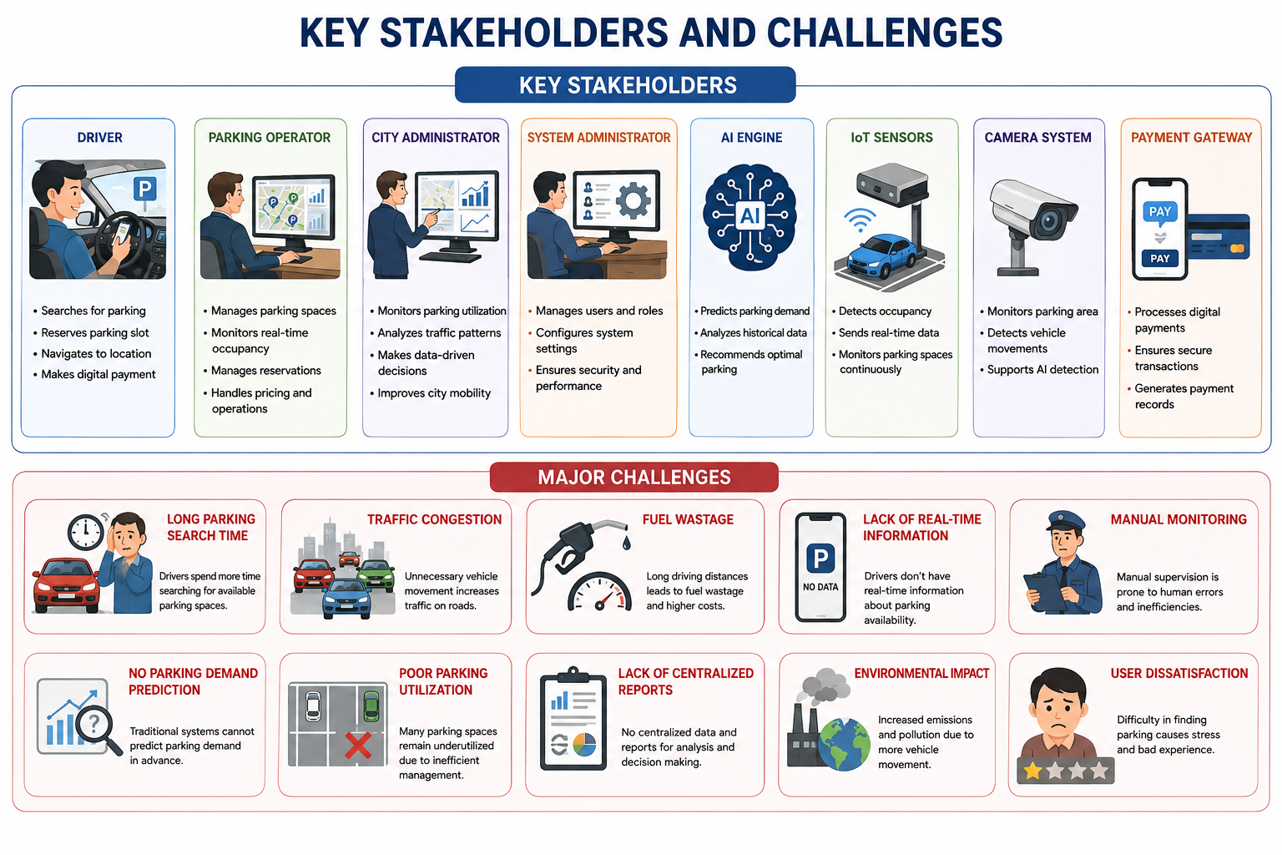

3. Analysis of the Current Approach
Existing parking systems depend on manual supervision or ticket-based methods.
Strengths:
• Low implementation cost
• Easy operation
• Minimal infrastructure
Limitations:
• No real-time monitoring
• Manual errors
• No reservation facility
• No AI prediction
• Inefficient parking utilization
Gap:
A smart AI-enabled parking platform is required for automated monitoring, prediction, navigation, reservation, and reporting.

4. Proposed Software Solution Using Software Engineering Principles
Overview:
The proposed system integrates AI, IoT sensors, CCTV cameras, GPS, cloud computing, and mobile applications to provide real-time parking management.
Functional Modules:
• User Management
• Parking Detection
• GPS Navigation
• Reservation
• Digital Payment
• AI Prediction
• Occupancy Monitoring
• Reports & Analytics
Functional Requirements:
• Register/Login
• Detect vacant parking spaces
• Display real-time availability
• Search nearby parking
• GPS navigation
• Reserve parking slot
• Online payment
• AI demand prediction
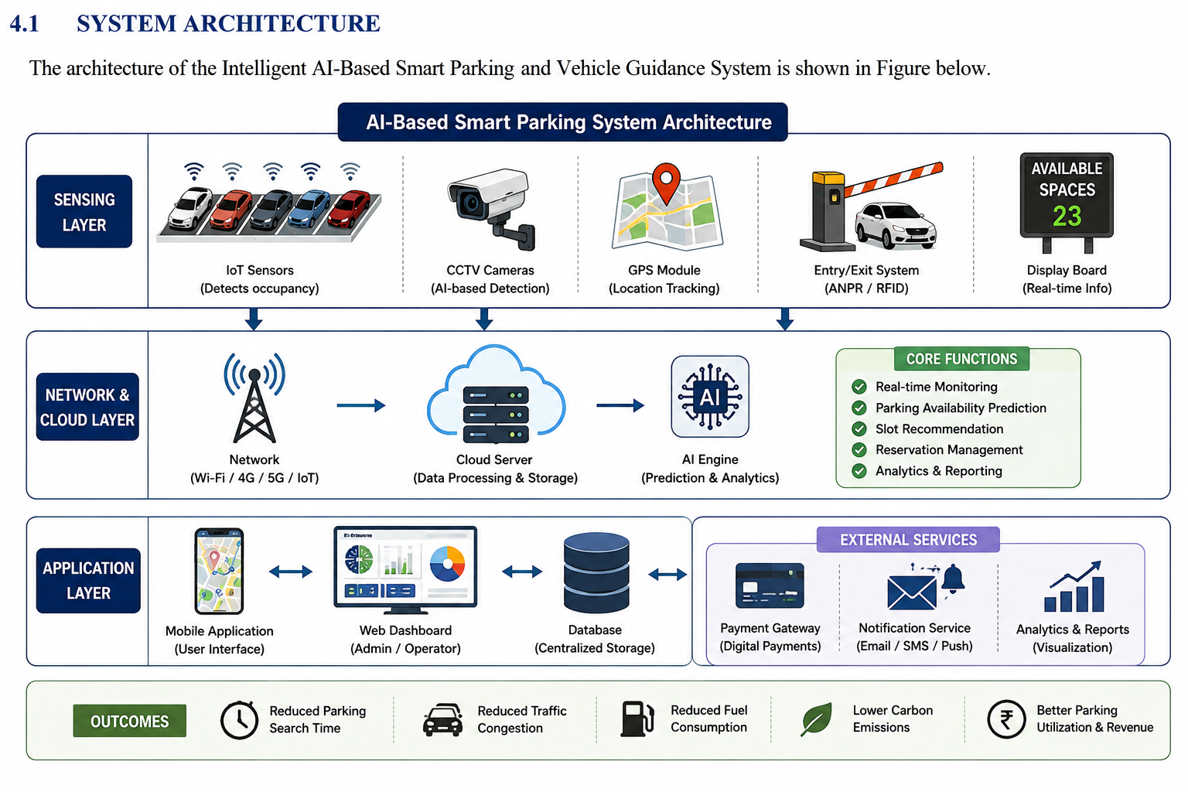

5. Justification of the Chosen Methodology
Agile Scrum supports iterative software development, continuous stakeholder feedback, frequent testing, and faster software delivery.

6. Expected Outcomes and Limitations
Expected Outcomes:
• Reduced parking search time
• Lower traffic congestion
• Reduced fuel consumption
• Improved parking utilization
• Better user convenience
• Increased parking revenue
• Reduced carbon emissions
Limitations:
• High IoT installation cost
• Internet dependency
• Hardware maintenance
• Data privacy concerns
• AI accuracy depends on data quality
Future Enhancements:
• EV charging support
• License Plate Recognition
• Dynamic parking pricing
• Voice assistant
• Smart City integration

7. Conclusion
The Intelligent AI-Based Smart Parking and Vehicle Guidance System provides an AI-driven solution for efficient parking management. By integrating AI, IoT, GPS, cloud computing, and digital payments, the system reduces congestion, improves parking utilization, enhances user convenience, and supports sustainable smart city development.

